**Document Intelligence Series — Part-1: Table Detection with YOLOv8**

[[Rajat Roy](https://medium.com/@iamrajatroy?source=post_page-----1fa0a198fd7--------------------------------)](https://medium.com/@iamrajatroy?source=post_page-----1fa0a198fd7--------------------------------)

[[MLearning.ai](https://medium.com/mlearning-ai?source=post_page-----1fa0a198fd7--------------------------------)](https://medium.com/mlearning-ai?source=post_page-----1fa0a198fd7--------------------------------)

[Rajat Roy](https://medium.com/@iamrajatroy?source=post_page-----1fa0a198fd7--------------------------------)

·

[Follow](https://medium.com/m/signin?actionUrl=https%3A%2F%2Fmedium.com%2F_%2Fsubscribe%2Fuser%2F28395b95796c&operation=register&redirect=https%3A%2F%2Fmedium.com%2Fmlearning-ai%2Fdocument-intelligence-series-part-1-table-detection-with-yolo-1fa0a198fd7&user=Rajat+Roy&userId=28395b95796c&source=post_page-28395b95796c----1fa0a198fd7---------------------post_header-----------)

Published in

[MLearning.ai](https://medium.com/mlearning-ai?source=post_page-----1fa0a198fd7--------------------------------)

·

3 min read

·

Aug 14, 2023

101

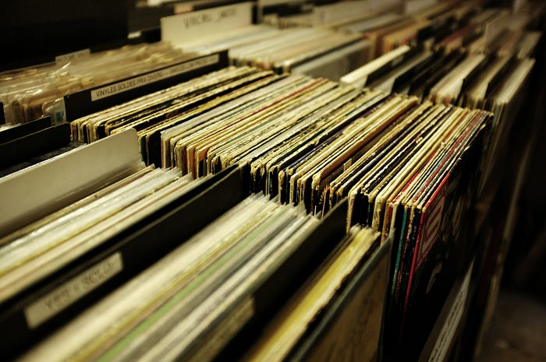

Photo by [Mr Cup / Fabien Barral](https://unsplash.com/@iammrcup?utm_source=medium&utm_medium=referral" \t "_blank) on [Unsplash](https://unsplash.com/?utm_source=medium&utm_medium=referral" \t "_blank)

**Introduction**

When dealing with unstructured data, you frequently encounter a situation where you must seek a resolution to efficiently retrieve information from a table within any document.

Pytesseract is one of python libraries which can help you perform OCR on documents to get all the text present in it. But what if you want only the tabular information?

In order to extract the tabular data, you must initially determine the table’s location within the document. Subsequently, you should extract and retain solely the tabular segment of the image. Ultimately, you can provide the cropped image to pytesseract for information extraction.

In this article, I am going to code to perform table detection on a given image and pass it on to pytesseract to extract the text from it.

**Code**

Let’s break down the process step by step. The initial stage involves table detection, which is facilitated by a Python library known as ***ultralytics***. This library encompasses a range of advanced tasks such as object detection, classification, and segmentation based on deep learning techniques. For this particular illustration, the ***yolov8*** model from ***ultralytics*** has been used.

Please note that the code is executed within the Google Colab environment.

1. Installing dependencies.

# Installing tesseract in system  
!sudo apt install tesseract-ocr  
  
# Installing required dependencies  
!pip install pytesseract transformers ultralyticsplus==0.0.23 ultralytics==8.0.21

2. Import Packages.

import numpy as np  
import pandas as pd  
pd.set\_option('display.max\_rows', 500)  
pd.set\_option('display.max\_columns', 500)  
pd.set\_option('display.width', 1000)  
  
import pytesseract  
from pytesseract import Output  
  
from ultralyticsplus import YOLO, render\_result  
from PIL import Image

3. Load Image

## Image downloaded from below link  
# https://stackoverflow.com/questions/50829874/how-to-find-table-like-structure-in-image  
  
image = './borderless\_table.jpg'  
  
img = Image.open(image)  
img

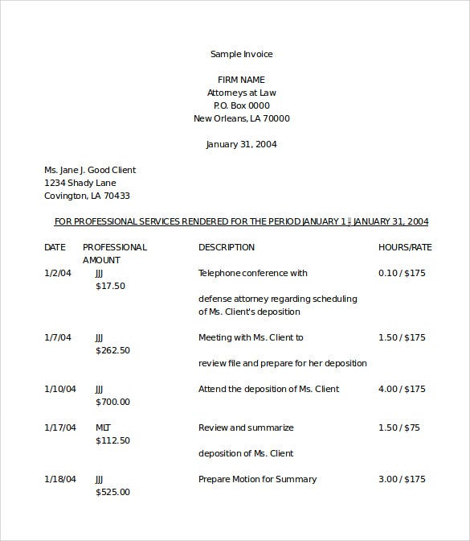

Sample Image with a borderless table

4. Initialize YOLOv8m model.

# load model  
model = YOLO('keremberke/yolov8m-table-extraction')  
  
# set model parameters  
model.overrides['conf'] = 0.25 # NMS confidence threshold  
model.overrides['iou'] = 0.45 # NMS IoU threshold  
model.overrides['agnostic\_nms'] = False # NMS class-agnostic  
model.overrides['max\_det'] = 1000 # maximum number of detections per image

5. Table Detection.

# perform inference  
results = model.predict(img)  
  
# observe results  
print('Boxes: ', results[0].boxes)  
render = render\_result(model=model, image=img, result=results[0])  
render

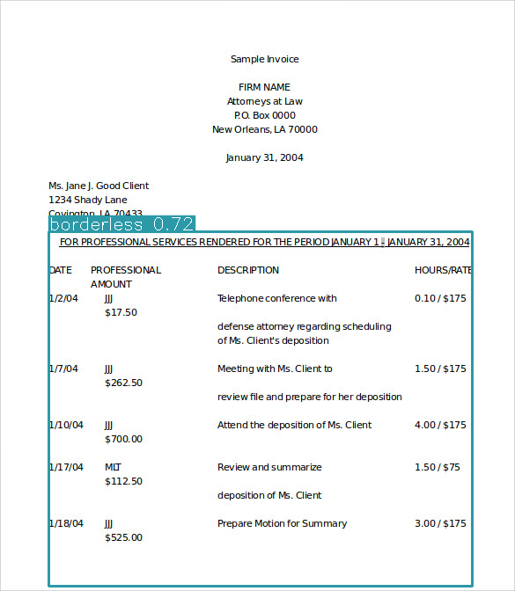

Model Output

6. Cropping tabular part from image.

x1, y1, x2, y2, \_, \_ = tuple(int(item) for item in results[0].boxes.data.numpy()[0])  
img = np.array(Image.open(image))  
#cropping  
cropped\_image = img[y1:y2, x1:x2]  
cropped\_image = Image.fromarray(cropped\_image)  
cropped\_image

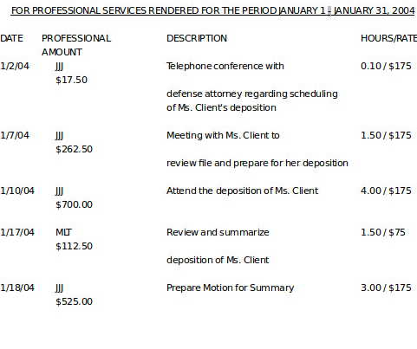

Cropped Table Region

7. Perform OCR.

ext\_df = pytesseract.image\_to\_data(cropped\_image, output\_type=Output.DATAFRAME, config="--psm 6 --oem 3")  
ext\_df.head()

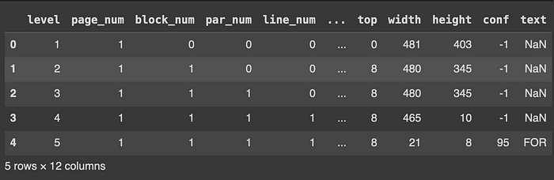

OCR Output Dataframe

**Conclusion**

Certainly, the **YOLO v8** model offers significant assistance in the realm of table detection, particularly for both bordered and borderless tables found within documents. I’m indeed eager to explore and experiment with its capabilities firsthand.

If you want to dig deep and know more about the model it can be found [here](https://ultralytics.com/yolov8).

***This message is for you!!***

*Are you a programming, AI, or machine learning enthusiast? Then you’ll love my blog on Medium! I regularly post about these topics and share my insights on the latest trends and tools in data science. If you find my content helpful, please like and follow my blog. And if you want to show some extra support, you can give a tip by clicking the button below. Thanks for your time and support!*

[**WRITER at MLearning.ai**](https://mlearning.substack.com/about)**/**[**AI Movie Director**](https://open.substack.com/pub/mlearning/p/8-stage-ai-movie-making-guide-10-top-ai-tools?r=z7zu8&utm_campaign=post&utm_medium=web)[**/imagine AI 3D Models**](https://open.substack.com/pub/mlearning/p/image-to-3d-one-click-ai-tool-modeling-video-txt?r=z7zu8&utm_campaign=post&utm_medium=web)

**[Mlearning.ai Submission Suggestions](https://medium.com/mlearning-ai/mlearning-ai-submission-suggestions-b51e2b130bfb?source=post_page-----1fa0a198fd7--------------------------------" \t "_blank)**

[How to become a writer on Mlearning.ai](https://medium.com/mlearning-ai/mlearning-ai-submission-suggestions-b51e2b130bfb?source=post_page-----1fa0a198fd7--------------------------------" \t "_blank)

[medium.com](https://medium.com/mlearning-ai/mlearning-ai-submission-suggestions-b51e2b130bfb?source=post_page-----1fa0a198fd7--------------------------------" \t "_blank)